**CO2101 – Database Project**

**Name: Favour Cole & Faithful Akachukwu Nwaleke-Emmanuel (Group 129)**

1. DB Green Project – Business Rules
   1. 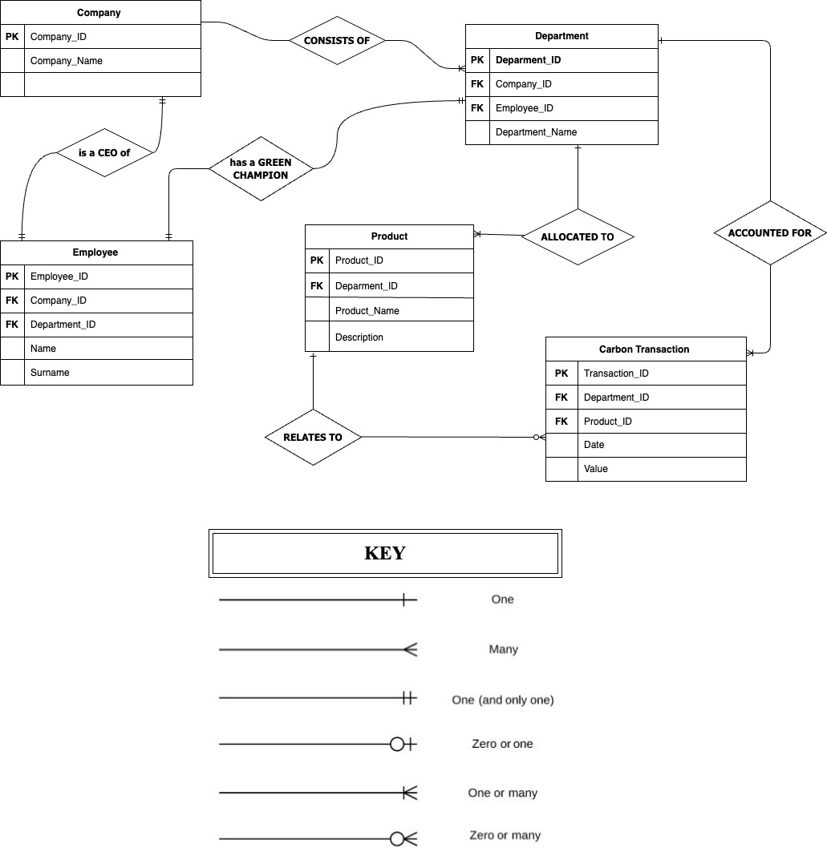
   2. A diagram of a product

      Description automatically generated

1.   Not all tables have a Primary key.

2.   One table isn’t named

3.   There's no Cardinal Representation

4.   They did not specify the attributes’ type.

5.   The primary keys don’t correspond with some of the tables

6.   Description is in the wrong table (should be in the product table)

7.   Junction table has no relationship with the Part table

8.   Doesn’t include necessary attributes such as the name of the product.

.

1. **Normalisation**

|  |  |
| --- | --- |
| **Primary Key (character name, player name)** | |
| George | Bob |
| Fred | Bob |
| ZeAlice | Alice |
| HisRoyalHighness | Charles |
| WarriorDelta | Delta |
| DeltaMage | Delta |

|  |  |  |
| --- | --- | --- |
| **Character Table** | | |
| Character Name | Character Level | Character Level |
| George | 50 | 800 |
| Fred | 50 | 1200 |
| ZeAlice | 21 | 350 |
| HisRoyalHighness | 30 | 470 |
| WarriorDelta | 50 | 1205 |
| DeltaMage | 2 | 60 |

|  |  |
| --- | --- |
| **Player Table** | |
| Player Name | Player Date Joined |
| Bob | 2014-12-31 |
| Alice | 2015-05-09 |
| Charles | 2016-09-09 |
| Delta | 2020-02-29 |

We verified that the table was already in the first normal form (1NF), so there was no requirement for me to normalize it to 1NF once more. The table possesses a composite primary key (character name, player name). Despite the repetition of entries such as Bob and Delta, the table remains in 1NF. It is crucial to note that it would not be in 1NF if, for instance, there were entries like George, Fred under the character name for Bob. To address redundancy and enhance efficiency, I further divided the tables into distinct entities. Consequently, Bob and Delta are not duplicated, each having a single date of joining. This separation eliminated the need for redundant entries and enhanced data integrity. We organized the data into three tables: one for primary keys, one exclusively for characters, and one for associated entities, allowing for seamless integration and effective management of data reliant on the primary key.

create database DATABASE11;

USE DATABASE11;

Create Table Office(

OfficeCode INT Primary Key,

City varchar(40),

PhoneNumber varchar(15),

AddressLine1 varchar(50),

AdrressLine2 varchar(50),

County varchar (70),

Country varchar (100),

PostalCode varchar (20),

Territory varchar (70)

);

Create Table Employee(

EmployeeNumber INT Primary Key,

LastName varchar(100),

FirstName varchar(100),

emailaddress varchar(40),

OfficeCode INT(40),

Jobtitle varchar(40),

OtherEmployee INT,

Foreign Key (OfficeCode) References Office(OfficeCode)

);

Create Table Customers(

CustomerNumber INT Primary Key,

CustomerFullName varchar(100),

CustomerLastName varchar(100),

PhoneNumber varchar(15),

AddressLine1 varchar(50),

AddressLine2 varchar(50),

City varchar(100),

County varchar(70),

PostalCode varchar(20),

Country varchar(100),

SalesAmount varchar(100),

RepresentiveEmployeeNumber INT,

CreditLimitNumber INT

);

Create Table Drugs(

ProductCode INT Primary Key,

ProductName varchar(20),

ProductLine varchar(100),

ScaleWeight varchar(100),

Vendor varchar(10),

Description_ TEXT(100),

QuantityInStock INT(99),

BuyingPrice DECIMAL(10, 3),

MSRP DECIMAL(10, 3)

);

Create Table _Order(

OrderNumber INT Primary Key,

OrderDate DATE,

RequiredDate DATE,

ShippedDate DATE,

OrderStatus varchar(160),

CustomerNumber INT

);

Create Table PaymentInformation(

CustomerNumber INT Primary Key,

ChequeNumber varchar(160),

PaymentDate DATE,

AmountPaidBycustomer INT,

Foreign Key (CustomerNumber) References Customer(CustomerNumber)

);

Create Table MututalInformation(

OrderNumber INT,

ProductCode INT,

QuantityOrdered INT,

Price DECIMAL(10, 3),

OrderLineNumber INT,

Foreign Key (OrderNumber) References _Order(OrderNumber)

);

Create Table ProductLine(

ProductLineText varchar(180) Primary Key,

Description_ TEXT(100),

Weebsitev varchar(150),

ProductImage varchar(150),

Products varchar(40)

);

-- > This is where we insert the data into the office table.

INSERT INTO Office (OfficeCode, City, Phone_Number, Address_Line1, Address_Line2, County, Country, Postal_Code, Territory)

VALUES

(4839, 'Rotterdam', '0673323453', '137 Kamphuisstraat Road', Null , 'South Holland', 'Netherlands', '1107 LX', 'South East'),

(2398, 'Amsterdam', '0683849362', '55 Stellendamstraat', 'Huis 278', 'The Hague', 'Netherlands', '2728 GB', 'North East'),

(3289, 'Amersfoort', '0689624567', '377 Vianenstraat', NULL, 'Zwolle', '', '2838 GC', 'Centrale Regio'),

(2390, 'Alkmaar', '0678922654', '38 Knotwilgstraat', 'Huis 249', 'Den Haag', 'Netherlands', '8283 GC', 'Oostervaart');

-- > This is where we insert the data into the Employee table.

INSERT INTO Employee (EmployeeNumber, LastName, FirstName, Extension, EmailAddress, OfficeCode, JobTitle, OtherEmployee)

VALUES

(10, 'Biornick', 'Asalibi', 'Extension_1', 'james.johns@example.com', 1, 'Manager', NULL),

(9, 'Moreno', 'Leerdam', 'Extension_2', 'christian.smith@example.com', 1, 'Assistant Manager', 1),

(8, 'Kyron', 'Fernand', 'Extension_3', 'shaun.doe@example.com', 2, 'Sales Associate', 1),

(7, 'Joel', 'Cole', 'Extension_4', 'robert.brown@example.com', 2, 'Sales Associate', 1);

-- > This is where we insert the data into the Pharmacutical Retail Customers table.

INSERT INTO PharmaceuticalRetailCustomers (CustomerNumber, CustomerFullName,PhoneNumber,Address_Line1,Address_Line2,City,County,Postal_Code,Country,Sales_Amount,Representative_Employee_Number,Credit_Limit_Number)

VALUES

(10, 'Asmare Lei', '0687965435', '900 Leeriestraat', NULL, 'Amstelveen', 'Gelderland', '2724 XH', 'Netherlands', 1900.00, 3, 4000),

(9, 'Phayden Redjo', '0678905456', '24 Nelsonstraat', NULL, 'Zwolle', 'Zeeland', '8393 DS', 'Netherlands', 2500.00, 4, 3000),

(8, 'Rudje Jerry', '0611234598', '24 Gemeenteplein', NULL, 'Gelderland', 'Texel', '9282 KL', 'Netherlands', 3510.00, 3, 4000),

(7, 'Ghermanio Snow', '0678904532', '18 Huisstraat', NULL, 'Maastricht', 'Terschechen', '9283 SD', 'Netherlands', 5400.00, 4, 8000);

-- > -- > This is where we insert the data into the Payment Info table.

INSERT INTO PaymentInformation (PaymentID, CustomerNumber, ChequeNumber, PaymentDate, AmountPaid)

VALUES

(1, 1, 'CHQ65410', '2006-09-11', 1900.00),

(2, 2, 'CHQ03862', '2022-08-03', 2500.00),

(3, 3, 'CHQ83410', '2021-09-25', 3510.00),

(4, 4, 'CHQ02581', '2007-05-15', 5400.00);

INSERT INTO Drugs (ProductCode, ProductName, ProductLineText, ScaleWeight, Vendor, Description_, QuantityInStock, BuyingPrice, MSRP)

VALUES

(188, 'Pil A', 'Medicijnen', 0.5, 'Pfizer Inc.', 'Pain reliever', 600, 16.00, 24.99),

(189, 'Pil B', 'Medicijnen', 0.75, 'GlaxoSmithKline', 'Cold medicine', 900, 8.50, 13.99),

(190, 'Pil C8', 'Vitamines', 0.25, 'Johnson & Johnson', 'Vitamin C supplement', 1700, 8.00, 17.99),

(191, 'Pil D2', 'Vitamines', 0.25, 'Novartis Pharmaceuticals', 'Multivitamin tablets', 700, 9.50, 15.99);

INSERT INTO Product_Line (Product_Line_Text, Description_, Website, Product_Image)

VALUES

('Medicijn', 'Goed voor je gezondheid', 'http://www.meds.com', "Medicijn.jpg"),

('Vitamine', 'Goed voor je nutritie', 'http://www.vitamins.com', "Vitamine.jpg"),

('Creatine', 'Energie product', 'http://www.requiredmeds.com', "Creatine.jpg"),

('Proteine', 'Spierbouw', 'http://www.randomvitamins.com',"Proteine.jpg" );

INSERT INTO Order_ (OrderNumber, OrderDate, RequireDDate, ShippedDate, OrderStatus, Comments, CustomerNumber)

VALUES

(3234, '2006-09-11', '2006-09-11', '2006-09-11', 'Verzonden', 'Normale bezorging', 1),

(3249, '2022-08-03', '2022-08-03', '2022-08-03', 'Verzonden', 'Speciale bezorging', 2),

(3493, '2021-09-25', '2021-09-25', '2021-09-25', 'Verzonden', 'Grote levering', 3),

(8334, '2007-05-15', '2007-05-15', NULL, 'In process tijdens de aflevering', 'Urgente berzorging', 4);

INSERT INTO MututalInformation (OrderLineNumber, OrderNumber, ProductCode, QuantityOrdered, Price)

VALUES

(10, 3234, 212, 37, 83.00),

(9, 3249, 123, 348, 89.00),

(8, 3493, 213, 3230, 14.00),

(7, 8334, 483, 28, 5.00);